**Springboard Introduction to Data Science Capstone Project: A Predictive Model for the 2016 U.S. Presidential Election on A County-by-County Basis**

Sujoy Gayen

Mentor: Mhairi McNeill

December 18, 2017

**Abstract**  
This project will create a model to predict on a county by county basis the percentage of the vote that the Republican and Democratic presidential candidates in the U.S. presidential 2016 election received. This model could be used by political analysts and campaign personnel in future presidential elections to predict the percentage of the vote that each of the two major party candidates would receive.

**Problem Setup**

The U.S. presidential election of 2016 was a surprising historic election. Against all odds, despite the predictions of nearly every political commentator, Donald Trump beat Hillary Clinton. Granted, Hillary Clinton won the popular vote. However, Donald Trump won enough votes in key states to win the electoral college. Many explanations have been put forward for Trump's victory. Many political commentators have noted that Trump appeared to win many traditionally Democratic voters, including voters that had voted for the Democratic president Barack Obama in the previous 2 presidential elections. Specifically, political commentators noted that Trump appeared to win an unusually large proportion of the white working class vote, especially in states such as Pennsylvania, Ohio, Wisconsin, and Michigan that had voted for Obama in the prior 2 elections. This capstone project aims to model the determinants of the 2016 presidential vote on a county by county basis.

**Data**

The data set is available here at this link: <https://github.com/Deleetdk/USA.county.data>

A good portion of this data came from the New York Time’s 2016 presidential election county-by-county-analysis.

The overall dataset includes 13 attributes for 3145 observations.

The observations come from each county in the United States.

The attributes with their corresponding variable names include:

* Fips: 4 digit county identification number
* Name of the county
* Average age of the inhabitants of the county: variable name is average_age
* Percentage of the population of the county that is white: percent_white
* Percentage of the population that lacks health insurance: percent_uninsured
* Percentage of the population that has an educational degree: percent_degree
* Average income of the inhabitants of the county: average_income
* State that the county is located in
* Percentage of the population of the county that voted for Republican candidate Donald Trump in 2016 presidential election: percent_republican
* Percentage of the population of the county that voted for Democrat candidate Hillary Clinton in 2016 presidential election: percent_democrat
* Percentage of the population of the county that voted for Republican candidate Mitt Romney in 2012 presidential election: percent_republican_2012
* Percentage of the population of the county that voted for Democrat candidate Barack Obama in 2012 presidential election: percent_democrat_2012

**Data Wrangling**

Upon initial inspection of the data, it is seen that the last 32 observations have missing values for the variables of county name and the percentage share of the Republican and Democratic vote share in both the 2012 and 2016 presidential elections 29 of these 32 missing observations are in the state of Alaska, which does not release county data for its presidential elections. Given the fact that these 32 observations were missing the dependent variable of interest and one of the key explanatory variables, the decision was made to not include these 32 missing observations in our analysis. Otherwise all the column names and values were organized and sensible, and no further data wrangling was needed.

**Exploratory Data Analysis of the Variables in the Model**

In this data set, my dependent variable is percent_republican, the percentage of the vote in each county that Republican candidate Donald Trump received in the 2016 presidential election.

The dependent variable of interest percent_republican and the 7 independent explanatory variables have the following summary statistics:

average_age percent_republican_2012 percent_white

Min. :18.00 Min. : 5.978 Min. : 2.50

1st Qu.:37.10 1st Qu.:50.538 1st Qu.:67.65

Median :39.90 Median :60.791 Median :86.30

Mean :39.86 Mean :59.653 Mean :78.75

3rd Qu.:42.80 3rd Qu.:70.277 3rd Qu.:94.30

Max. :62.50 Max. :95.862 Max. :99.20

percent_degree percent_uninsured

Min. : 3.70 Min. : 3.10

1st Qu.:13.10 1st Qu.:14.00

Median :16.80 Median :17.70

Mean :19.01 Mean :17.99

3rd Qu.:22.60 3rd Qu.:21.50

Max. :71.00 Max. :46.00

percent_unemployed average_income percent_republican

Min. : 0.800 Min. : 0 Min. : 4.122

1st Qu.: 5.800 1st Qu.:22332 1st Qu.:54.960

Median : 7.500 Median :24825 Median :66.715

Mean : 7.706 Mean :25461 Mean :63.600

3rd Qu.: 9.300 3rd Qu.:27549 3rd Qu.:75.033

Max. :28.300 Max. :56674 Max. :95.273

Also of importance for an initial explanatory analysis is a list of the correlation coefficient between each independent explanatory variable and the dependent variable percent_republican, shown below.

#average_age 0.3325677

#percent_republican_2012 0.9347904

#percent_white 0.5365550

#percent_uninsured 0.1950089

#percent_degree -0.4936432

#percent_unemployed -0.2728920

#average_income -0.1996266

Let’s now take a closer look at our 8 varibales.

1. Percent_republican: This variable is measuring the Republican percentage of the vote in the 2016 presidential election. It appears to be roughly normally distributed with the median and mean relatively close in value(66.7% and 63.6%) respectively. The first quintile is 55.0% and the 3rd quintile is 75.0% with a min of 4.1% and a max of 95.3%.
2. Percent_republican 2012: This variable is the most strongly correlated with percent_republican with a correlation coefficient of 0.93, given that party affiliation usually doesn’t change over 4 years. Like percent_republican it is normally distributed, with the median and mean being very close in value(60.8% and 59.7%) respectively. Below is a plot showing the strong linear correlation between percent_republican 2012 and percent_republican.

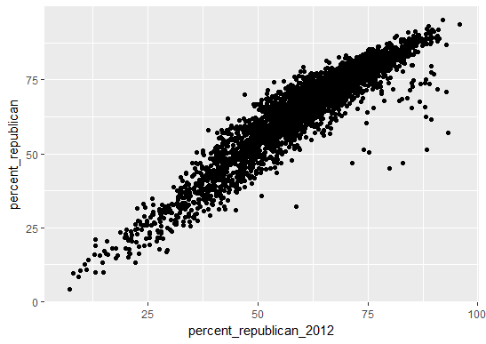

1. Percent_white: After percent_republican_2012, this is the 2nd most highly correlated variable with percent_republican with a correlation coefficient of 0.54, as seen in the scatter plot below. This variable appears to be skewed, with the median being greater than the mean (86.3% vs 78.8% respectively). In the scatter plot, it can be seen that there is a very high concentration of points on the right side with percent_white between% 90 to 100% and percent_republican between 50 and 75%.

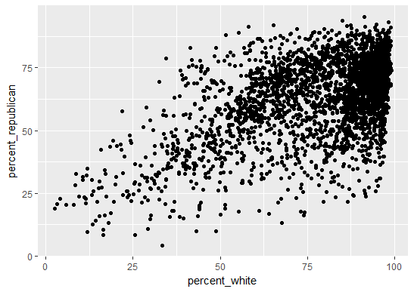

1. Percent_degree: This variable has a moderately strong negative correlation with percent_republican on -0.49. The scatter plot below shows this correlation. Most of the points lie in the upper left corner with percent_degree between 10 to 20% and percent_republican between 55% and 75%. Most of the counties where percent_degree is 40% or more have a Republican share of the vote that is less than 50%. It appears to be approximately normally distributed, perhaps with a slight skew, with a median of 16.8% and mean of 19.0%.

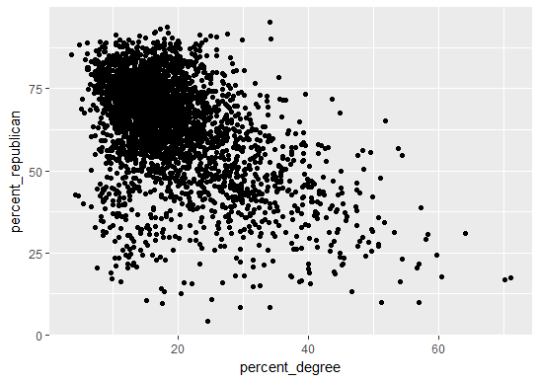

1. Average_age: This variable is normally distributed, with median and mean being virtually the same (39.90 years and 39.86 years respectively). This variable has a small to moderate-sized positive correlation with percent_republican; the correation coefficient is 0.33. A plot is shown below.

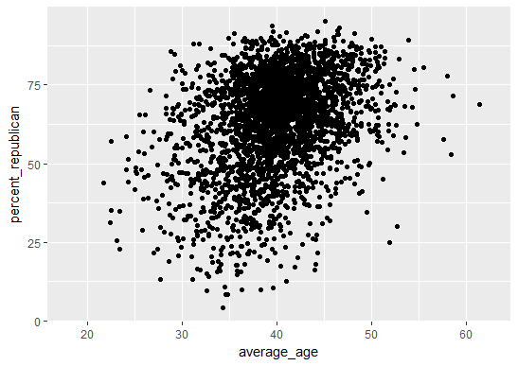

1. Percent_unemployed: This variable is normally distributed, with median and mean being virtually the same (7.5% and 7.7% respectively). This variable has a small to moderate-sized negatve correlation with percent_republican; the correation coefficient is -0.27. A plot is shown below.

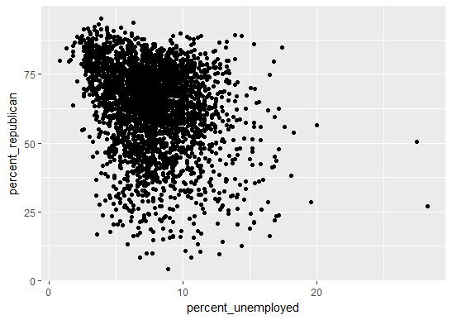

1. Percent_uninsured: This variable is normally distributed, with median and mean being virtually the same (17.70% and 17.99 respectively). This variable has a small positive correlation with percent_republican; the correlation coefficient is 0.195. This would mean that the R-squared value is less than 0.04; percent_unemployed explains less than 4% of the variability in percent_republican, which does not indicate a good fit for a model from an initial standpoint. A plot is shown below. An inspection of the plot shows that it is hard to discern a clear positive linear correlation.

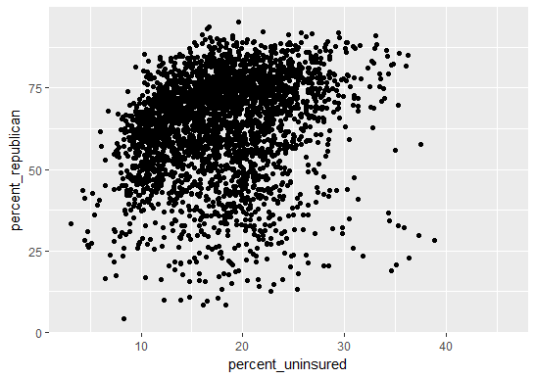

1. Average_income: This variable is normally distributed, with median and mean both being around $25,000. This variable has a small negative correlation with percent_republican; the correlation coefficient is approximately -0.20. This would mean that the R-squared value is labout 0.04; the individual average annual income explains less than 4% of the variability in the 2016 share of the Republican vote, which does not indicate a good fit for a model from an initial standpoint. A plot is shown below. An inspection of the plot shows that it is hard to discern a clear negative linear correlation.

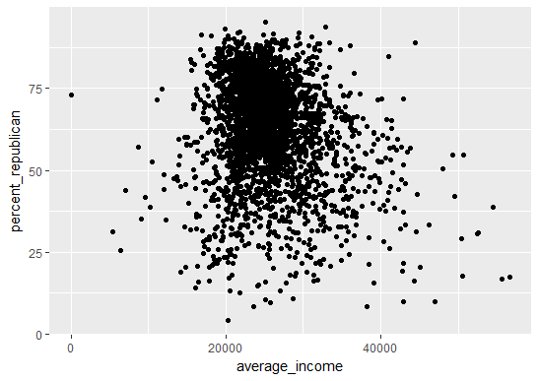

Based on this initial exploratory analysis, it appears that percent_republican_2012, percent_white, and percent_degree will be good explanatory variables for our model. Machine testing will need to be done to determine if the other 4 independent variables will also be good explanatory variables. Based on this initial assessment, there is reason to suspect that percent_unemployed and average_income may not be good variables for our linear regression model.

**Machine Learning on the 2016 Presidential Election Data Set: Creating a Predictive Model**

In this data set, my dependent variable is percent_republican, the percentage of the vote in each county that Republican candidate Donald Trump received in the 2016 presidential election. Given that percent_republican is a continuous variable, a natural starting point for a predictive model of percent_republican is a linear regression model.

Initially, the 3145 observations were divided into a training set and a test set, with 80% of the observations in the training set and 20% in the test set.

As a starting point, my initial model included all of the following: independent explanatory variables in the dataset:

1. average_age: the average age of the county’s population
2. percent_republican_2012: the 2012 Republican presidential candidate’s share of the vote
3. percent_white: the percentage of the county’s population that is white
4. percent_uninsured: the percentage of the county’s population that lacks health insurance
5. percent_degree: percentage of county’s population that has an educational degree
6. average_income: average annual income of the county’s population
7. percent_unemployed: percentage of the county’s population that is unemployed

I did not include percent_democrat_2012 because it would be highly linearly correlated with percent_republican 2012, since percent_republican_2012+percent_democrat_2012 is approximately 100%, excluding the 3rd party vote. In the same vain, percent_democrat can be considered another dependent variable that is highly linearly correlated with our variable of interest, percent republican.

Here is a summary (taken from R-Studio) of this initial model:

Model 1 (all 7 explanatory variables)

lm(formula = percent_republican ~ percent_republican_2012 + average_income +

average_age + percent_white + percent_uninsured + percent_degree +

percent_unemployed, data = na.omit(train))

Residuals:

Min 1Q Median 3Q Max

-27.9186 -1.5361 0.0924 1.8183 11.5049

Coefficients:

Estimate Std. Error t value Pr(>|t|)

(Intercept) 8.511e+00 9.118e-01 9.333 < 2e-16 ***

percent_republican_2012 7.916e-01 6.854e-03 115.485 < 2e-16 ***

average_income 3.600e-05 1.635e-05 2.202 0.0278 *

average_age 1.283e-01 1.532e-02 8.375 < 2e-16 ***

percent_white 1.545e-01 5.734e-03 26.943 < 2e-16 ***

percent_uninsured 2.839e-02 1.918e-02 1.481 0.1388

percent_degree -4.816e-01 9.867e-03 -48.810 < 2e-16 ***

percent_unemployed -2.247e-01 2.771e-02 -8.109 7.93e-16 ***

---

Signif. codes: 0 ‘***’ 0.001 ‘**’ 0.01 ‘*’ 0.05 ‘.’ 0.1 ‘ ’ 1

Residual standard error: 3.158 on 2482 degrees of freedom

Multiple R-squared: 0.9589, Adjusted R-squared: 0.9587

F-statistic: 8265 on 7 and 2482 DF, p-value: < 2.2e-16

In this initial linear model, model 1, all the explanatory variables are significant at an alpha =0.05 level, except for percent_uninsured, which has a p-value of 0.139. The adjusted

R-squared for this model was 0.9587. The SSE (sum of standard errors) was 24748.3, and the root mean square error was 3.15. After obtaining of a summary of this initial model, I decided to check to see if the signs of the coefficients for each variable in the model matched the sign of the correlation coefficient of each variable with our dependent variable, percent_republican. The only variable that had mismatched signs was average_income, which had a positive coefficient in the initial linear regression model but a negative correlation coefficient with percent_republican.

This mismatch in signs indicated problems with collinearity, so I created a correlation matrix among all the independent explanatory variables to check for collinearity.

Among the 7 independent explanatory variables in our intial model, the pairs of variables with the highest degree of collinearity were:

1) average_age and percent_white (r=0.456)

2) percent_republican_2012 and percent_white(r=0.433)

# 3) percent_white and percent_uninsured(r= -0.473)

# 4) percent_uninsured and average income (r=0.436)

# 5) percent_degree and average income (r=0.51)

After this initial analysis, I decided to remove the average_income variable from the model for the 3 following reasons:

1. Mismatched signs
2. High degree of collinearity with percent_uninsured and percent_degree
3. Correlation coefficient with dependent variable percent_republican was only -0.20.

My reasoning was that if average_income was removed, perhaps percent_uninsured would become a significant variable in the model.

Therefore, the second model I tested, model_income_removed, had all of the explanatory variables in model 1, except for average_income. Here is a summary of this 2nd model.

Model 2 (6 explanatory variables, average_income removed)

lm(formula = percent_republican ~ percent_republican_2012 + percent_degree +

average_age + percent_white + percent_unemployed + percent_uninsured,

data = na.omit(train))

Residuals:

Min 1Q Median 3Q Max

-28.244 -1.564 0.095 1.822 11.577

Coefficients:

Estimate Std. Error t value Pr(>|t|)

(Intercept) 9.412875 0.815182 11.547 < 2e-16 ***

percent_republican_2012 0.795446 0.006632 119.936 < 2e-16 ***

percent_degree -0.471674 0.008788 -53.673 < 2e-16 ***

average_age 0.131899 0.015244 8.653 < 2e-16 ***

percent_white 0.151230 0.005544 27.281 < 2e-16 ***

percent_unemployed -0.221358 0.027687 -7.995 1.96e-15 ***

percent_uninsured 0.010694 0.017424 0.614 0.539

---

Signif. codes: 0 ‘***’ 0.001 ‘**’ 0.01 ‘*’ 0.05 ‘.’ 0.1 ‘ ’ 1

Residual standard error: 3.16 on 2483 degrees of freedom

Multiple R-squared: 0.9588, Adjusted R-squared: 0.9587

F-statistic: 9627 on 6 and 2483 DF, p-value: < 2.2e-16

In this model, percent_uninsured was still not a significant variable with p value of 0.54. All other explanatory variables were highly significant. Given that percent_uninsured was highly correlated with percent_white and that the correlation coefficient between percent_uninsured and percent_republican was 0.195, I decided to remove percent_uninsured from the model.

Thus, I formed my final predictive model for percent republican, summarized below.

Final model(5 explanatory variables, average_income and percent_uninsured removed)

|  |
| --- |
| lm(formula = percent_republican ~ percent_republican_2012 + percent_degree +  average_age + percent_white + percent_unemployed, data = na.omit(train))  Residuals:  Min 1Q Median 3Q Max  -28.269 -1.566 0.093 1.824 11.532  Coefficients:  Estimate Std. Error t value Pr(>|t|)  (Intercept) 9.579112 0.768778 12.460 < 2e-16 ***  percent_republican_2012 0.797708 0.005513 144.697 < 2e-16 ***  percent_degree -0.472347 0.008718 -54.180 < 2e-16 ***  average_age 0.133391 0.015046 8.865 < 2e-16 ***  percent_white 0.148985 0.004164 35.775 < 2e-16 ***  percent_unemployed -0.218614 0.027320 -8.002 1.86e-15 ***  ---  Signif. codes: 0 ‘***’ 0.001 ‘**’ 0.01 ‘*’ 0.05 ‘.’ 0.1 ‘ ’ 1  Residual standard error: 3.16 on 2484 degrees of freedom  Multiple R-squared: 0.9588, Adjusted R-squared: 0.9587  F-statistic: 1.156e+04 on 5 and 2484 DF, p-value: < 2.2e-16 |

This final model was a good model. After removing two variables due to problems with

collinearity, the simplified 5 variable model has an adjusted R2 that has remained constant at a high value of 0.9587. All five variables were highly significant and had coefficients with the correct sign. Compared to our initial model with 7 explanatory variables, this simplified 5 variable model had insignificantly increased SSE and MRSE( 24748 to 24800 and 3.15 to 3.16 respectively).

I then plotted the final predictive model (model_income_and_uninsued_removed) to test for linear regression assumptions. Based on these plots, the predictive model meets the assumptions necessary for linear regression. The average of the residuals appears to be close to 0, for the most part, as seen in the plot of residual values versus the model’s predicted value of Republican vote share. The red line in the plot indicates the mean residual value; it increases to slightly above 0 at predicted values around 65% and decreased to slightly below 0 at predicted values around 80%. Overall, however, we can assume that the mean residual value is close to 0.

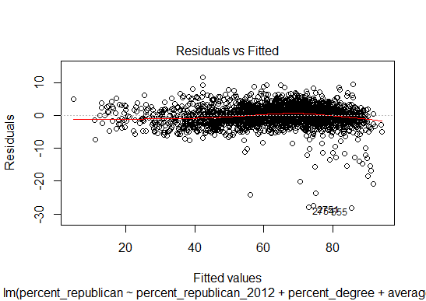

Another assumption of linear regressions is that the residual values are normally distributed. This plot of standardized residuals versus theoretical quantiles shows that for the most part, the residual values are distributed normally. There is a small minority of outlier values at the right side of the plot; these represent predicted values where the error was in the negative direction, meaning that for these values, the model underpredicted the Republican share of the vote. However, for a significant majority of the dataset, the residual values are normally distributed.

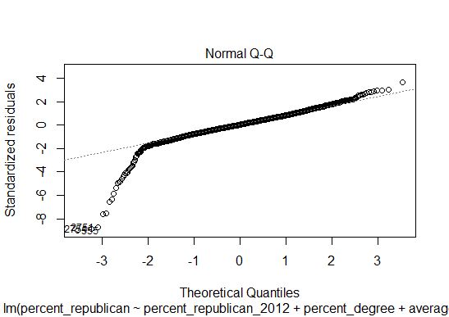

This final model was built using the train data set. I took this final model and used it on the test data set to create a new variable in the test data set, predict_republican. This variable consisted of all the predicted values of the 2016 presidential election Republican percentage vote share using this model that was built using the training set. The correlation coefficient between the predicted 2016 presidential election Republican percentage vote share(predict_republican) and the actual percentage(percent_republican) in the test dataset was 0.974. R-squared value was 0.974^2=0.949. The high R and R-squared values indicate that this final predictive model is a good fit for the test data.

**Interpreting the Model/Conclusion**

Percent_republican_2012 is the most significant explanatory variable. With a coefficient of 0.798 in the linear regression model, it can be predicted the for every 1 percentage increase in the Republican candidate’s share of the vote in the 2012 presidential election, the Republican candidate’s share of the vote in the 2016 presidential election will increase by 0.8 percentage points. This is not surprising given that for most people party affiliation does not change over a relatively short time period of 4 years.

Another significant explanatory variable is percent_white. With a coefficient of 0.149, it can be predicted that for every 1 percentage point increase in the portion of the population that is white, the 2016 Republican share of the presidential election vote increases by almost 0.15 percentage points. This is not surprising given that in the past 30 to 40 years, if not longer, minority voters tend to vote for Democrat candidates, while Republican candidates poll better among white voters.

Another significant explanatory variable is average_age. With a coefficient of 0.133, the model predicts that for every 1 year increase in the average age of the county population, the 2016 Republican share of the presidential vote in that county will increase by 0.13 percentage points. This is not surprising given that Republicans historically tend to poll better with older people.

Of interest, both percent_degree and percent_unemployed are the two explanatory variables in the model that are negatively correlated with the Republican share of the vote in 2016. As the percentage of the population that has a college degree or that is unemployed increases, the Republican share of the vote decreases, and the Democrat share of the vote increases. Of note, of the 5 variables in this model, percent_degree and percent_unemployed are the two with the highest degree of correlation with the average income variable. However, they are correlated with average income in opposite directions. Percent_degree is positively correlated with average_income, while percent_unemployed is negatively correlated with average income, both of which make intutitive sense. These conflicting correlations are probably contributing to the fact that average_income is such a poor explanatory variable for the Republican share of the vote, leading it to not be included in the model. In practical terms, this means that Democrats should target both rich and poor counties. They should target counties with a high proportion of educational degree-bearing individuals; these counties are more likely to be rich. However, Democrats should also focus on turning out the vote in counties with a high percentage of unemployed individuals; these counties are more likely to be poor.

With regards to overall voter turnout strategy, Republican political operatives should focus on counties where a larger percentage of the population is elderly, white, lacking an educational degree, and employed. On the other hand, Democrats should be focusing on counties where a larger percentage of the population is young, non-white, college-educated or higher, and unemployed.

Index

Model 1: (All 7 explanatory variables)

lm(formula = percent_republican ~ percent_republican_2012 + average_income +

average_age + percent_white + percent_uninsured + percent_degree +

percent_unemployed, data = na.omit(train))

Residuals:

Min 1Q Median 3Q Max

-27.9186 -1.5361 0.0924 1.8183 11.5049

Coefficients:

Estimate Std. Error t value Pr(>|t|)

(Intercept) 8.511e+00 9.118e-01 9.333 < 2e-16 ***

percent_republican_2012 7.916e-01 6.854e-03 115.485 < 2e-16 ***

average_income 3.600e-05 1.635e-05 2.202 0.0278 *

average_age 1.283e-01 1.532e-02 8.375 < 2e-16 ***

percent_white 1.545e-01 5.734e-03 26.943 < 2e-16 ***

percent_uninsured 2.839e-02 1.918e-02 1.481 0.1388

percent_degree -4.816e-01 9.867e-03 -48.810 < 2e-16 ***

percent_unemployed -2.247e-01 2.771e-02 -8.109 7.93e-16 ***

---

Signif. codes: 0 ‘***’ 0.001 ‘**’ 0.01 ‘*’ 0.05 ‘.’ 0.1 ‘ ’ 1

Residual standard error: 3.158 on 2482 degrees of freedom

Multiple R-squared: 0.9589, Adjusted R-squared: 0.9587

F-statistic: 8265 on 7 and 2482 DF, p-value: < 2.2e-16

Model 2 (6 explanatory variables, average_income removed)

lm(formula = percent_republican ~ percent_republican_2012 + percent_degree +

average_age + percent_white + percent_unemployed + percent_uninsured,

data = na.omit(train))

Residuals:

Min 1Q Median 3Q Max

-28.244 -1.564 0.095 1.822 11.577

Coefficients:

Estimate Std. Error t value Pr(>|t|)

(Intercept) 9.412875 0.815182 11.547 < 2e-16 ***

percent_republican_2012 0.795446 0.006632 119.936 < 2e-16 ***

percent_degree -0.471674 0.008788 -53.673 < 2e-16 ***

average_age 0.131899 0.015244 8.653 < 2e-16 ***

percent_white 0.151230 0.005544 27.281 < 2e-16 ***

percent_unemployed -0.221358 0.027687 -7.995 1.96e-15 ***

percent_uninsured 0.010694 0.017424 0.614 0.539

---

Signif. codes: 0 ‘***’ 0.001 ‘**’ 0.01 ‘*’ 0.05 ‘.’ 0.1 ‘ ’ 1

Residual standard error: 3.16 on 2483 degrees of freedom

Multiple R-squared: 0.9588, Adjusted R-squared: 0.9587

F-statistic: 9627 on 6 and 2483 DF, p-value: < 2.2e-16

Final model(5 explanatory variables, average_income and percent_uninsured removed)

|  |
| --- |
| lm(formula = percent_republican ~ percent_republican_2012 + percent_degree +  average_age + percent_white + percent_unemployed, data = na.omit(train))  Residuals:  Min 1Q Median 3Q Max  -28.269 -1.566 0.093 1.824 11.532  Coefficients:  Estimate Std. Error t value Pr(>|t|)  (Intercept) 9.579112 0.768778 12.460 < 2e-16 ***  percent_republican_2012 0.797708 0.005513 144.697 < 2e-16 ***  percent_degree -0.472347 0.008718 -54.180 < 2e-16 ***  average_age 0.133391 0.015046 8.865 < 2e-16 ***  percent_white 0.148985 0.004164 35.775 < 2e-16 ***  percent_unemployed -0.218614 0.027320 -8.002 1.86e-15 ***  ---  Signif. codes: 0 ‘***’ 0.001 ‘**’ 0.01 ‘*’ 0.05 ‘.’ 0.1 ‘ ’ 1  Residual standard error: 3.16 on 2484 degrees of freedom  Multiple R-squared: 0.9588, Adjusted R-squared: 0.9587  F-statistic: 1.156e+04 on 5 and 2484 DF, p-value: < 2.2e-16 |
|  |
| |  | | --- | |  | |